**REQUIREMENT DOCUMENT**

**Requirement of Online Cloth store:**

Our node.js Website provides

1. Customer should be able to sign up for our website
2. Customer should be able to login to the cloth store website
3. Customer sees all clothes available in the store as a list
4. Customer can filter the products on clicking on the docked tab on left of the page (E.g.: Men, Women may be main option and pyjamas, night wear, party wear might be the sub category)
5. Each product should be displayed as a card with the following properties
   1. 1-4 images (slides on hover)
   2. Seller
   3. Description of the product in one line
   4. Real Price
   5. Offer
   6. Net Price
6. On clicking on each product, the customer should be able to the details of the product
   1. Brand
   2. Color
   3. Fabric
   4. Price
   5. Cart Symbol
   6. Should be able to zoom an image
   7. Seller etc
7. Customer should be able to increase and decrease the quantity(q) of each product and the net price displayed should be increased
8. Customer can add one or more products into their basket
9. Customer should be able to edit the quantity of the products in the basket and the price should be updated accordingly
10. Customer should be able to see no of items on top of the cart if there are any products in the cart
11. Customer should be able to retrieve the products in their basket on clicking on the cart symbol on the top right corner
12. Customer should be able to delete the products in their basket
13. Total amount of the cart should be displayed/updated each time customer adds or deletes a product from it
14. Customer should be able to log out of the website

**INSPIRATIONS OF THE UI DESIGN:**

**Home Page after logging in:**

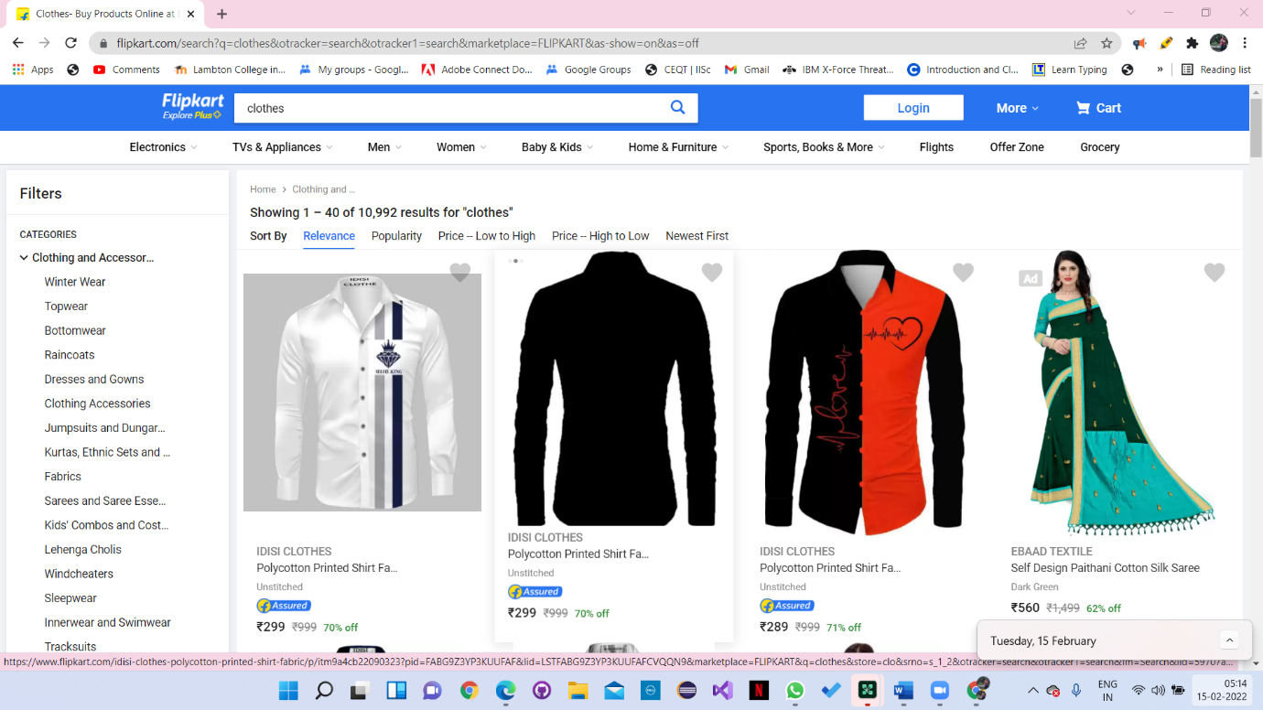

**Detail Page of a selected item**

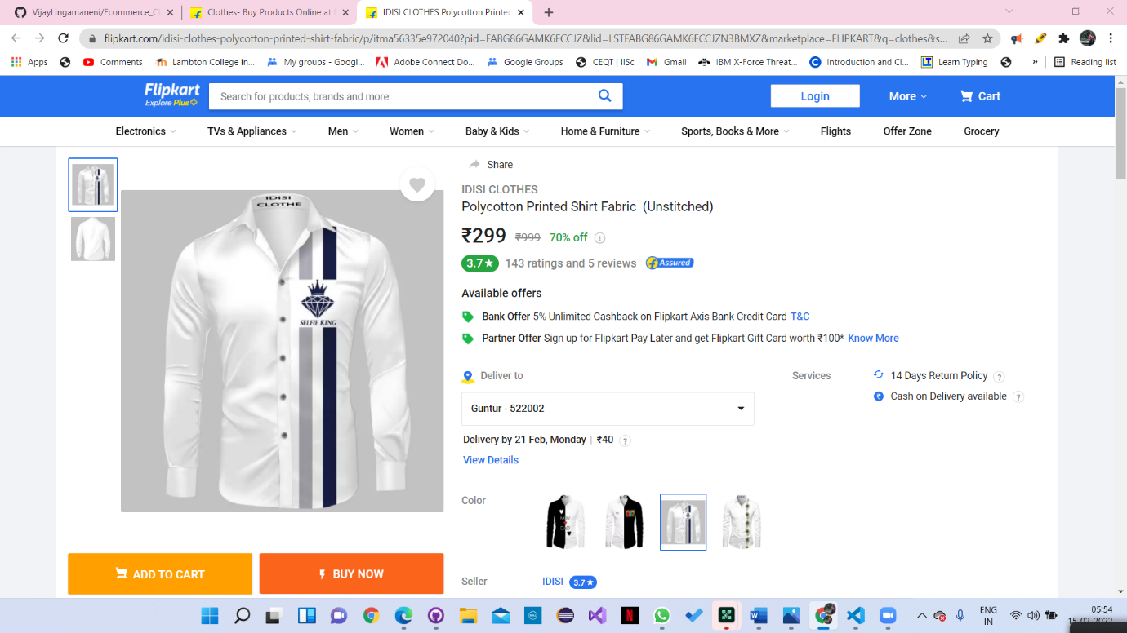

**ALL SQL STATEMENTS:**

**PROJECT CODE:**

**CONFIGURATION FILES: (JavaScript, HTML, CSS, SQL)**

**SCREENSHOTS OF FINISHED PRODUCT:**